**Can-Am Off-Road Expands MY22 Lineup with Focus on**

**Enhanced Comfort in its Hardworking Defender Lineup**

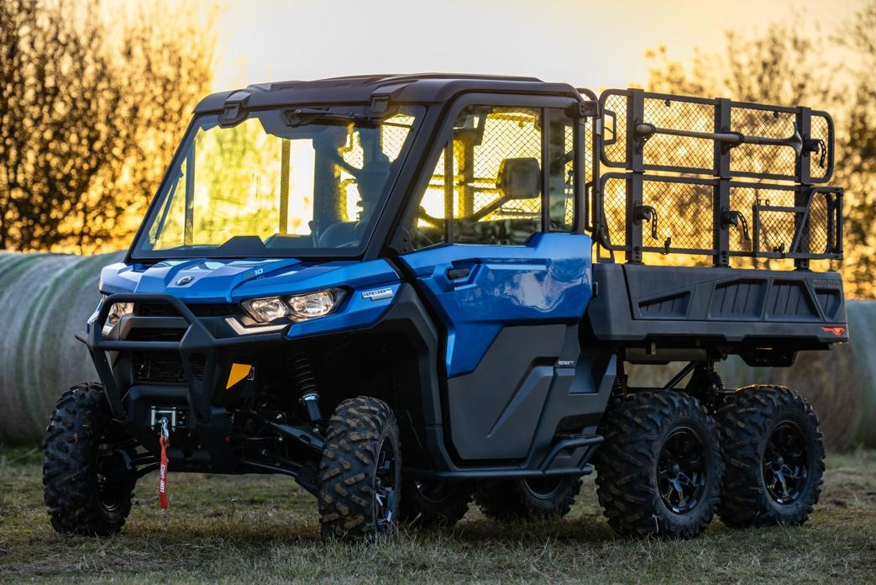

*The all-new 2022 Can-Am Defender 6x6 Limited sets the bar for performance and comfort. ©BRP 2022*

**Valcourt, Québec, Canada, February 14, 2022** – BRP Inc. (TSX:DOO; NASDAQ:DOOO) continues to see record-high demand for its powersports vehicles, including its award-winning lineup of Can-Am Off-Road vehicles. The company intends to relentlessly build on its momentum and push boundaries, with ongoing investments in innovation and new product development. For the Can-Am Off-Road brand, that means more vehicle news for the MY22 lineup, this time focused on bringing enhanced comfort to the work day.

Since first introduced in 2020, the Can-Am Defender 6x6 has been a workhorse, capable of going places other side-by-side vehicles (SSV) could only dream. It is a go-to vehicle for hunters, ranchers, and landowners looking for an incredibly capable and reliable machine. And now, with the **2022 Can-Am Defender 6x6 Limited**, all that capability is available with further comfort. The fully enclosed cab and industry-exclusive auto climate control with air conditioning and heat will ensure all those miserably hot and cold work days are a lot more comfortable.

In addition, the Can-Am Defender 6x6 maintains its industry-leading towing capacity of up to 3,000 lbs., along with the industry’s largest-capacity cargo box with hydraulic power tilt. Plus, a new color-matched door design means people will now enjoy increased visibility, along with better protection and sealing.

“The Can-Am Defender 6x6 is the most capable side-by-side vehicle we’ve ever built,” said Julie Tourville, Director, Global Marketing, Can-Am Off-Road at BRP. “It is the ideal choice for people who require an incredibly tough machine that’s built to match the demanding needs in their off-road way of life. And now with added comfort, it’s the best of both worlds.”

Also new to the MY22 lineup is a **Can-Am Defender MAX Lone Star CAB**. BRP launched the Defender Lone Star Edition in 2018 as a utility-recreational vehicle loaded with premium features. And it just got a lot more premium with the addition of climate control. A full enclosure and premium full doors (front electric and rear full roll down) keep the air conditioning and heat in, maximizing comfort. The new Defender MAX Lone Star CAB also comes factory-installed with a JL Audio Roof that lets riders set the soundtrack for the day.

BRP unveiled its first wave of MY22 Can-Am Off-Road news back in August across both its SSV and All-Terrain Vehicle (ATV) lineups. That news included a 200-hp Can-Am Maverick X3, two new engine options across the SSV lineup, and the expansion of the acclaimed Visco-4Lok 4-wheel drive system on select ATV models. With this latest round of product news, MY22 is the most complete Can-Am Off-Road lineup to date, helping to reinforce the brand’s incredible momentum.

The MY22 Can-Am Off-Road vehicle lineup offers something for all riders, regardless if their Off-Road Livin’ focuses on work, performance, or adventuring. For more technical details and product specs, as well as information on the complete lineup of Can-Am Off-Road vehicles, visit <https://can-am.brp.com/off-road>.

**About BRP**

We are a global leader in the world of powersports vehicles, propulsion systems and boats built on over 75 years of ingenuity and intensive consumer focus. Our portfolio of industry-leading and distinctive products includes Ski-Doo and Lynx snowmobiles, Sea-Doo watercraft, Can-Am on and off-road vehicles, Alumacraft, Manitou, Quintrex boats and Rotax marine propulsion systems as well as Rotax engines for karts and recreational aircraft. We complete our lines of products with a dedicated parts, accessories and apparel business to fully enhance the riding experience. With annual sales of CA$6.0 billion from over 130 countries, our global workforce is made up of more

than 14,500 driven, resourceful people.

[www.brp.com](http://www.brp.com/)

[@BRPNews](https://twitter.com/BRPnews)

Ski-Doo, Lynx, Sea-Doo, Can-Am, Rotax, Alumacraft, Manitou, Quintrex, Stacer, Savage, Evinrude and the BRP logo are trademarks of Bombardier Recreational Products Inc. or its affiliates. All other trademarks are the property of their respective owners.

-30-

**For information:**

BRP Communication Department

[media@brp.com](mailto:media@brp.com)